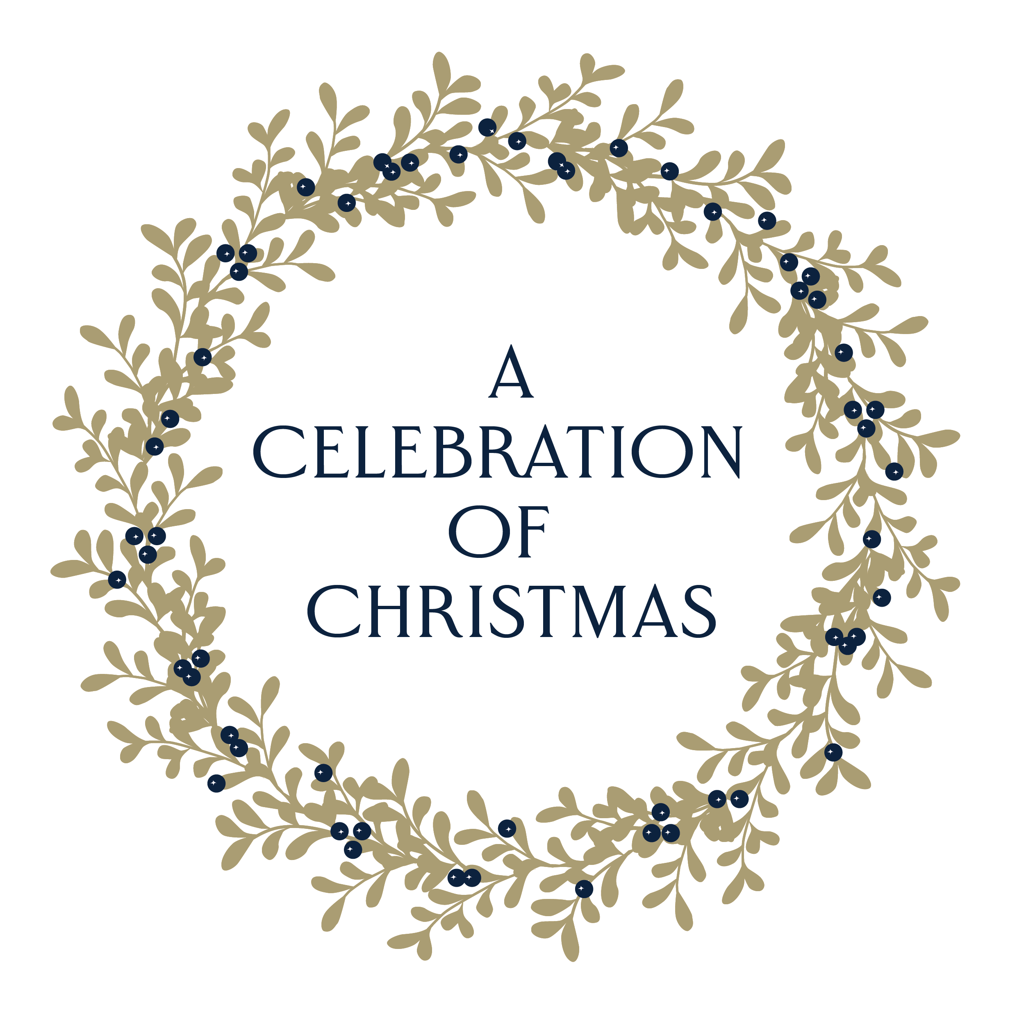

Embargoed for 17 October 2019

‘A CELEBRATION OF CHRISTMAS’ COMES TO MARLBOROUGH

Event: A Celebration of Christmas – a Christmas Carol Service in aid of the Stroke Association
Date: Thursday 19th December 2019
Time: Festive drinks from 6pm; service at 7pm
Venue: Marlborough College Chapel, Bath Road, Marlborough, Wiltshire, SN8 1PA
Tickets: This is an advanced ticket-only event
Tickets are £20 each from www.celebrationofchristmas.co.uk or from the White Horse Bookshop on Marlborough’s High Street
Website: www.celebrationofchristmas.co.uk
Enquiries: celebrationofchristmas@outlook.com

A Christmas carol service in aid of the Stroke Association will take place in Marlborough College Chapel at 7pm on Thursday 19th December. Guests are invited to enjoy an evening of seasonal celebrity readings and wonderful musical performances, as well as traditional carols. The service is kindly supported by Royal Patron HRH the Duke of Kent KG.

Media only - for further information:
Rachel Inglefield
Tel: 07979 813907
Email: rachel.inglefield@hotmail.co.uk

